



HTML5-Level 3-Practice Case Study 2

(For Classroom Training, Virtual Classroom, Webinar, Dovetail and Assessments)

Ver 3.1

## Infrastructure Section

i. Hardware, Software Specification

This section captures the hardware and software specifications for the effective delivery of the course.

**a. Hardware Specification**

|  |  |
| --- | --- |
| **Server Specification** | NIL |
| **Desktop / Client Specification** |  |
| **Others** | IE 7, IE 8,IE 9, Google Chrome, Safari ,Firefox |

**b. Software** **Specification**

| **#** | **Name of the software (s) to be installed** | **Version** | **License available in RAMS?**  **(Yes/No)** | **License available in RAMS for onsite?**  **(Yes/No)** | **Description of any patch to be installed** | **Can be used through Tool Wire / SoftGrid?** |
| --- | --- | --- | --- | --- | --- | --- |
| 1 | IE | 7,8,9 | Yes | Yes |  | Yes |
| 2 | Firefox | 9 | Yes | Yes |  | Yes |
| 3 | Google chrome | 16 | Yes | Yes |  | Yes |
| 4 | Safari | 5.1 | Yes | Yes |  | Yes |
| 5 | Opera | 11.6 | Yes | Yes |  | Yes |
| 6 | Mozilla |  | Yes | Yes |  | Yes |

**Instruction for installing the software in the “Tool Wire/SoftGrid” environment *(if the response is ‘Yes’ in the last column in the above table)*:**

| **#** | **Name of the software** | **Instruction** |
| --- | --- | --- |
| 1 | IE 7,8,9 |  |
| 2 | Firefox 9 |  |
| 3 | Google chrome 16 |  |
| 4 | Safari 5.1 |  |
| 5 | Opera 11.6 |  |
| 6 | Mozilla |  |

# Software Installation Checklist



Cognizant Academy offers continuing education for the associates to be confident and successful in their position, as well as improve and grow their skill set to reach new challenges and opportunities. These education opportunities reach across the enterprise, engaging individuals, teams, departments, management and executives. Cognizant academy develop a website to provide various offering which will be used by cognizant associates around the country and will be accessed from various devices like desktop browsers, mobiles, tablets etc.

As a HTML5 Developer, you have been assigned with the task of developing one module of Cognizant Academy web site. The module contains below pages

1. Home page - Provides details of Cognizant Academy and training requirements form which captures the training requirements from the associate.
2. Thank you page – Thank you page appear after the user successfully submit the feedback form.

# Screen 1:

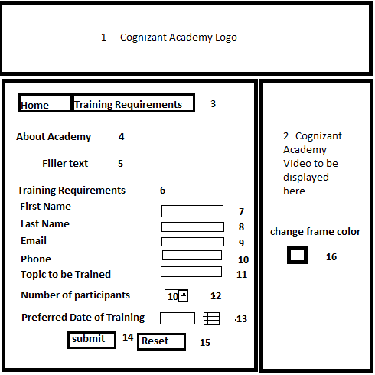

Note : The numbers 1 to 16 displayed in the screen are not “On screen” content rather references used to explain the fields in the later part of this document (it should not appear in the actual HTML page is being developed by you).

# Note on the UI Screen 1

1. The page should have 3 sections as displayed above
2. The borders of each section should have rounded corners(Not shown in the screen 1 design)

# Screen 1 Field Description

|  |  |  |
| --- | --- | --- |
| **S.No** | **Field Description** | **Constraints** |
| 1 | The Cognizant Academy Logo should be displayed in the header. The image should correctly fit into the header | The header should not be printed when the page is sent for printing |
| 2 | The Cognizant Academy Demo Video should be displayed here. Video is provided in the case study. The video should have the controls play, seek and volume. | If the browser does not support the video feature, then the message "your browser does not support video" should be displayed to the user. If the browser supports the video tag and does not support the type of the video, then "Your browser does not support this type of video should be displayed. |
| 3 | Tabbed pane with hyperlink. The "Home" link should refers to the samepage. The "Training Requirements" link should refers to the "Training Requirements" section of the same page. | Use HTML5 features to display the tabbed pane. |
| 4 | Section with Header "About Academy" |  |
| 5 | The filler text is " Cognizant Academy offers continuing education for the associates to be confident and successful in their position, as well as improve and grow their skill set to reach new challenges and opportunities. These education opportunities reach across the enterprise, engaging individuals, teams, departments, management and executives.  Cognizant understands that our employees need to continually explore new ideas and methodologies to make their jobs more productive, efficient, and successful. Virtual classrooms provide on-demand access across North America, India, the Philippines, and beyond. This multi-cultural engagement creates better channels of communication while fostering the exchange of best practices. " |  |
| 6 | Section with Header "Training Requirements" |  |
| 7 | Text box with First Name as Label. The text "Enter First Name" should be the default text displayed in the text box. When the user starts entering the the value, the default text should disapper |  |
| 8 | Text box with Last Name as Label |  |
| 9 | Text box with Email label | Should validate the email address format. Should NOT use Javascript for validation. HTML5 feature should be used. |
| 10 | Text box with Phone as label. The text "Enter mobile number" should be the default text displayed in the text box. When the user enters the phone number, the default text should disapper | Should validated for numeric digits. Use Only HTML5 features. |
| 11 | Text box with "Topics to be Trained" Label. Autocomplete feature should be available to the user for the following options Java Technologies, Mainframe, .Net frameworks, Datawarehousing, Database | Donot use combo box. It should be done with <input> element |
| 12 | Text box with "Number of Participants" as Label. | The text box should allow the user to select the number only. The minimum value that can be selected is 10 and maximum value should be 30. Don’t use "Javascript" and html5 features. |
| 13 | Date picker with preferred date of Training | Should NOT use "Javascript" to create date picker. Use HTML5 features |
| 14 | Button with "Submit" as caption. On clicking this button , validations should be performed and Thank you page should be displayed on successful validation. | Refers to Screen 2 "Thank you for registration" page |
| 15 | Button with Reset as caption. On clicking this button, all field should be reset. |  |
| 16 | A color picker with Label "Change frame Color" which will change the background color of the frame which contains "About Academy" and "Training requirements" dynamically. | should NOT use "Javascript" to create Color picker |

# Features to be implemented in the HTML page

1. The user should not able to view the cached copy of the “Home Page” even if the user is NOT connected the internet.
2. All the fields are mandatory. If value for any field is not entered, the appropriate messages should be displayed.

**Screen 2:**

On clicking the submit button, if no error messages the below screen will be displayed.

Thank you for submitting your training requirements. Our training coordinator will reach you in 24hrs to process the request.